A PROJECT REPORT ON

## AUTOMATIC NUMBER PLATE RECOGNISATION SYSTEM (ANPR)

Submitted to

KIIT Deemed to be University

In Partial Fulfillment of the Requirement for the Award

BACHELOR’S DEGREE IN COMPUTER SCIENCE & ENGINEERING

By

AYUSH KUMAR RAI-1705301 DIPAK KUMAR SINHA-1705306

NIRAJ KUMAR KANNAUJIYA-1705331 UTKARSH KUMAR-1705378

VISHAL KUMAR SINGH-1705760

UNDER THE GUIDANCE OF

## PROF: AMIYA RANJAN PANDA



SCHOOL OF COMPUTER ENGINEERING

### KALINGA INSTITUTE OF INDUSTRIAL TECHNOLOGY

BHUBANESWAR, ODISHA – 751024 APRIL 2020

# KIIT Deemed to be University

#### School of Computer Engineering Bhubaneswar, ODISHA 751024

CERTIFICATE

This is to certify that the project entitled

**“AUTOMATIC NUMBER PLATE RECOGNISATION”**

Submitted by:

**AYUSH KUMAR RAI-1705301 DIPAK KUMAR SINHA-1705306**

**NIRAJ KUMAR KANNAUJIYA-1705331 UTKARSH KUMAR-1705378**

**VISHAL KUMAR SINGH-1705760**

is a record of Bonafide work carried out by them, in the partial fulfillment of the requirement for the award of Degree of Bachelor of Engineering (Computer Science & Engineering OR Computer Science and Communication Engineering) at KIIT Deemed to be university, Bhubaneswar. This work is done during year 2019-2020, under our guidance.

Date: **Prof. AMYA RANJAN PANDA**

#### Project Guide

**ACKNOWLEDGEMENTS**

We are profoundly grateful to Prof. AMYA RANJAN PANDA for his expert guidance and encouragement throughout to see that this project rights its target since its commencement to its completion. The work is a team effort minus which the completion of this project was not possible.

## AYUSH KUMAR RAI DIPAK KUMAR SINHA

**NIRAJ KUMAR KANNAUJIYA**

**UTKARSH KUMAR VISHAL KUMAR SINGH**

**ABSTRACT**

Automatic License Plate Recognition system is a real time embedded system which automatically recognizes the license plate of vehicles. There are many applications ranging from complex security systems to common areas and from parking admission to urban traffic control. Automatic license plate recognition (ALPR) has complex characteristics due to diverse effects such as of light and speed. Most of the ALPR systems are built using proprietary tools like Matlab. This paper presents an alter- native method of implementing ALPR systems using Free Soft- ware including Python and the Open Computer Vision Library

**Keywords --** *License plate, Computer Vision, Pattern Recognition, Python, OCR.*

## CONTENTS

**Topic Page No**

1. Introduction 06
   1. Motivation and Related Works 07
   2. Objective 08
2. Definitions and Overview 09-12
   1. Capture 09
   2. Preprocess 10
   3. Localize 10
   4. CCA 11
   5. Segmentation 11
   6. Character Recognition 12
3. Project Planning 13
   1. Methodology

4. Tools 14-15

* 1. Python 14
  2. OpenCV 14
  3. Tesseract 15

1. Implementation 16-18
2. Results and Discussions 19-20
   1. Future Scope 20
3. Conclusions 21
4. Appendix B 22
5. References 23

## I NTRODUCTION

The scientific world is deploying research in intelligent transportation systems which have a significant impact on peoples´ lives. Automatic License Plate Recognition (ALPR) is a computer vision technology to extract the license number of vehicles from images. It is an embedded system which has numerous applications and challenges. Typical ALPR systems are implemented using proprietary technologies and hence are costly. This closed approach also prevents further research and development of the system. With the rise of free and open source technologies the computing world is lifted to new heights. People from different communities interact in a multi-cultural environment to develop solutions for mans never ending problems. One of the notable contribution of the open source community to the scientific world is Python. Intel’s researches in Computer Vision bore the fruit called Open Computer Vision (OpenCV) library, which can support computer vision development.

#### Motivation

For the standard number plates the automatic number plate recognition becomes very easy to read and recognizes the character. In India the vehicle number plates has no standard size and font so it become very difficult to read and recognize the characters of the number plate. So flexible algorithm required solve this problem.

#### Related Works

The methods discussed in preceding sections are common methods for plate detection. Apart from these methods, various literature discussed method for plate detection. As most of the methods discussed in these literatures use more than one approach, it is not possible to do category wise discussion. Different number plate segmentation algorithms are discussed below.

In [5], for faster detection of region of interest (ROI) a technique called sliding concentric window (SCW) is developed. It is a two step method contains two concentric windows moving from upper left corner of the image. Then statistical measurements in both windows were calculated based on the segmentation rule which says that if the ratio of the mean or median in the two windows exceeds a threshold, which is set by the, then the central pixel of the windows is considered to belong to an ROI. The two windows stop sliding after the whole image is scanned. The threshold value can be decided based on trial and error basis. The connected component analysis is also used to have overall success rate of 96%. The experiment was carried out on Pentium IV at 3.0 GHz with 512-MB RAM and took 111ms of processing time for number plate segmentation.

A cascade framework was used in [33] for developing fast algorithm for real time vehicle number plate detection. In this framework a compact frame detection module is used to segment number plate. This module contains three steps: First - Generation of Plate Region Candidates which is used to reject non plate regions by using gradient features. Second – Extraction of complex plate regions which contains three steps to identify plate region and reject non plate regions. Third – plate verification is used to make sure that no non plate regions are extracted in preceding steps. The experiment was carried out on 3-GHz Intel Pentium 4 personal computer.

To locate Indian number plate, a feature based number plate localization is proposed in [34]. The authors use Otsu’s method to convert gray scale images into binary images. It is a seven-step procedure to extract number plate without any background image from vehicle image.

#### Objective

The Automatic Number Plate Recognition is a system which is designed to help in recognition of number plates of vehicle. The purpose of designing this system is to develop security system. This system performs the various functions like number plate detection of vehicles, then processing them and using the processed data for storing and allows the vehicle to enter or reject the vehicle. This system is based upon the image processing technology which involves the number of image processing algorithm. The objective of this ANPR system is to design an efficient automatic vehicle number plate and used the system for various application like Toll collection, Parking System, border crossing, traffic control, stolen cars, etc.The ANPR system consist of mainly four stages to implement the system which are Image acquisition, Number plate extraction, Number plate segmentation and Character recognitio

## D EFINITIONS And OVERVIEW

#### PROPOSED SYSTEM

In India, basically, there are two kinds of license-plates, black characters in white plate and black characters in yellow plate. The former for private vehicles and latter for commer- cial, public service vehicles. The system tries to address these two categories of plates. The high-level block diagram of the proposed system is shown in Fig. 1.

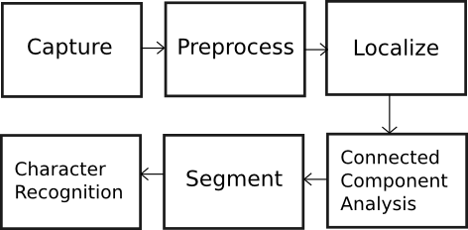

Fig. 1. Proposed System

* 1. **Capture**

The image of the vehicle is captured using a high resolution photographic camera. A better choice is an Infrared (IR) camera. The camera may be rolled and pitched with respect Character recognition is generally very sensitive to the skew. The readable characters can become distorted due to the obliqueness of the camera. Using a better camera with more definition and resolution will increase the success ratio of the system.

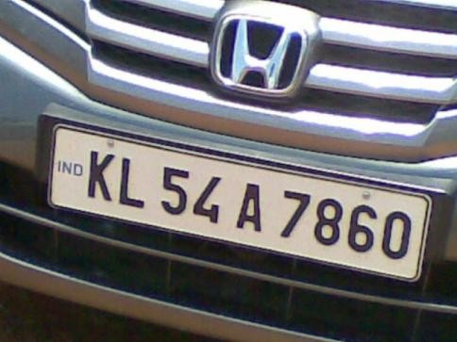

Fig. 2. Captured Image (Original image)

### Preprocess

Preprocessing is the set algorithms applied on the image to enhance the quality. It is an important and common phase in any computer vision system. For the present system preprocessing involves two processes: **Resize** – The image size from the camera might be large and can drive the system slow. It is to be resized to a feasible aspect ratio. **Convert Colour Space** – Images captured using IR or photo- graphic cameras will be either in raw format or encoded into some multimedia standards. Normally, these images will be in RGB mode, with three channels (viz. red, green and blue).

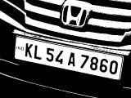

Fig. 3. Localization (Thresholded image)

Number of channels defines the amount colour information available on the image. The image has to be converted to grayscale.

### Localize

Rear or front part of the vehicle is captured into an image. The image certainly contains other parts of the vehicle and the environment, which are of no requirement to the system. The area in the image that interests us is the license plate and needs to be localized from the noise. Localization is basically a process of binarizing the image. As shown in Fig. 3, the image is converted to black and white. There are two motivations for this operation –1. Highlighting characters and 2. Suppressing background.

Localization is done by an image processing technique called Thresholding. The pixels of the image are truncated to two values depending upon the value of threshold. Threshold requires pre-image analysis for identifying the suitable threshold value. Adaptive thresholding technique determines a local optimal threshold value for each image pixel so as to avoid the problem originating from non-uniform illumination.

### Connected Component Analysis

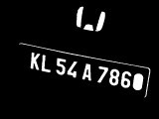

Fig. 4. Connected Components (Blobs)

In order to eliminate undesired image areas, a connected component algorithm is first applied to the binarized plate candidate. Connected component analysis is performed to identify the characters in the image. Basic idea is to traverse through the image and find the connected pixels. Each of the connected components (blobs) are labelled and extracted. Fig. 4 shows the filtered blobs.

### Segmentation

Segmentation is the process of cropping out the labelled blobs. These blobs are expected to be the required portion of the license number. A special algorithm called Image Scissoring[1] is introduced here. In this algorithm, the license plate is vertically scanned and scissored at the row on which there is no white pixel and the scissored area is copied into a new matrix, as in Fig. 5.



Fig. 5. Segmented blobs

There are unwanted blobs even after segmentation. These are classified using special algorithms.

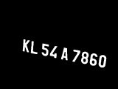

Fig. 6. Classified Blobs

### Character Recognition

Finally, the selected blobs are send to a Optical Character Recognition (OCR) Engine, which returns the ASCII of the license number.

# P ROJECT PLANNING

#### Agenda

To enlist and visualize the steps to finalize the project To break down the problem into a number of smaller tasks Allocating tasks among members and setting tentative deadlines for completion

**3.1. METHODOLOGY USED TO ANALYZE THE ABOVE PROBLEM:**

* + 1. Under Machine Learning this problem falls under the Image processing problem and could be solved using OpenCv

1. With the help of the comparison in accuracy and efficiency of the several algorithms used based on the research done we came to a conclusion to examine the problem using OpenCv image processing algorithms.

We have used a sample image and video for training the model. Steps involved in training the model are as follows:

* 1. Preprocess i.e. Re-sizing and changing the image to gray scale.
  2. Localise i.e. converting the image to binary for segmentation
  3. Segmentation
  4. Character Recognisation using Tesseract

## TOOLS:

* 1. **.1 Python**

Python is a remarkably powerful dynamic, object-oriented programming language that is used in a wide variety of application domains. It offers strong support for integration with other languages and tools, and comes with extensive standard libraries. To be precise, the following are some distinguishing features of Python:

* Very clear, readable syntax.
* Strong introspection capabilities.
* Full modularity.
* Exception-based error handling.
* High level dynamic data types.
* Supports object oriented, imperative and functional pro-gramming styles.
* Embeddable.
* ScalableMature
  1. **.2 OpenCV**

OpenCV is a library of programming functions for real time computer vision originally developed by Intel and now supported by Willogarage. It is free for use under the open source BSD license. The library has more than five hundred optimized algorithms. It is used around the world, with forty thousand people in the user group. Uses range from interactive art, to mine inspection, and advanced robotics. The library is mainly written in C, which makes it portable to some specific platforms such as Digital Signal Processor. Wrappers for languages such as C, Python, Ruby and Java (using JavaCV) have been developed to encourage adoption by a wider audience. The recent releases have interfaces for C++. It focuses mainly on real-time image processing. OpenCV is a cross-platform library, which can run on Linux, Mac OS and Windows. To date, OpenCV is the best open source computer vision library that developers and researchers can think of.

## Tesseract

Tesseract is a free software OCR engine that was developed at HP between 1984 and 1994. HP released it to the commu-nity in 2005. Tesseract was introduced at the 1995 UNLV Annual Test OCR Accuracy [2] and is currently developed by Google released under the Apache License. It can now recognize 6 languages, and is fully UTF8 capable. Developers can train Tesseract with their own fonts and character mapping to obtain perfect efficiency.

## IMPLEMENTATION

The implimentation of the project is done to find out the plate number on sample image

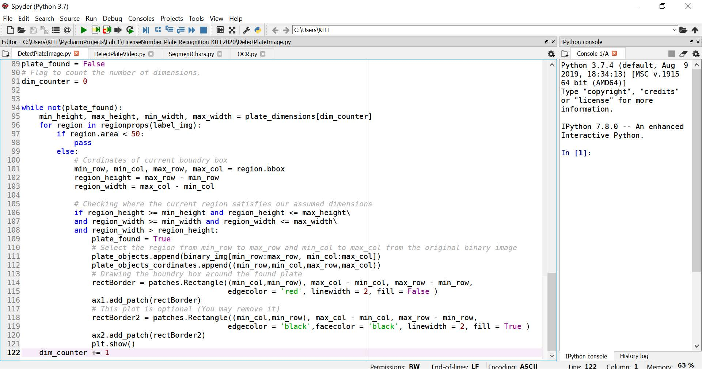

## Specimen of the used code for image preprocessing

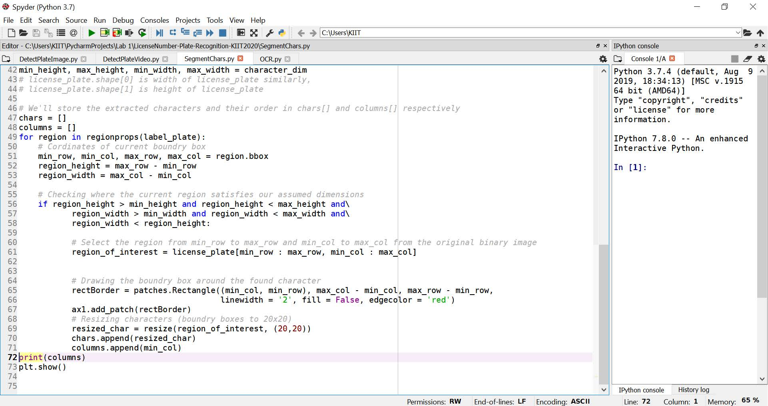

**Specimen of the used code for segmentation**

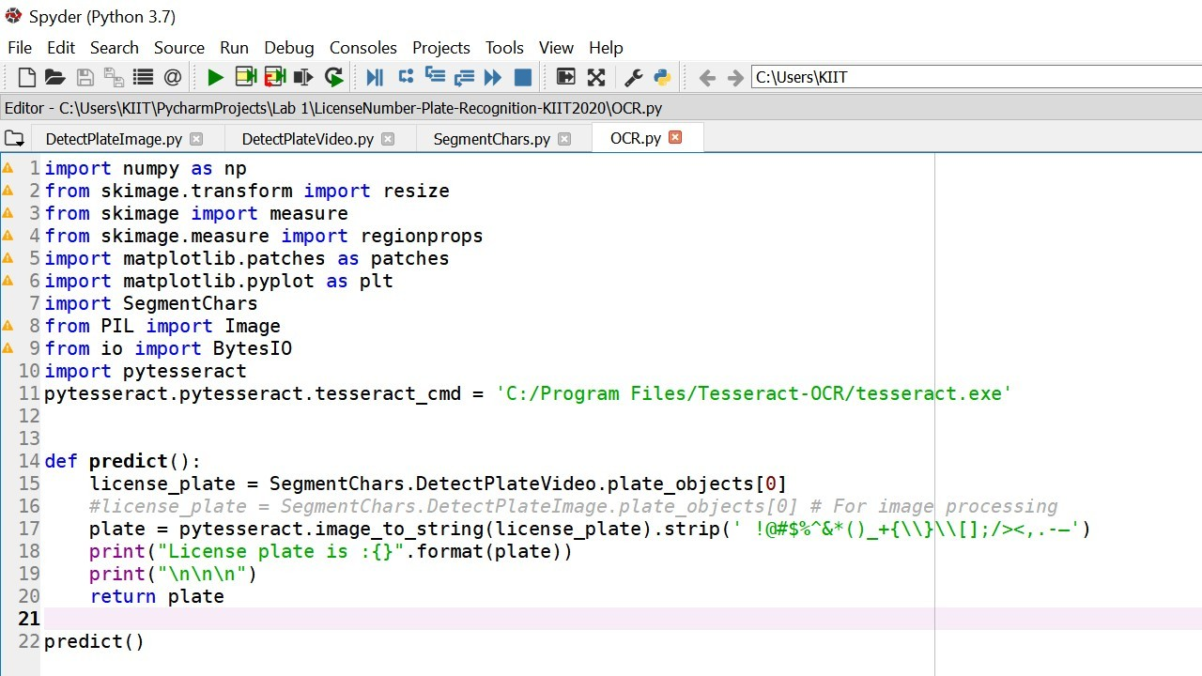

**Specimen of the used code for character recognisation using**

**tesseract**

* + 1. **Results and Discussions**

The purpose of this project starts from the assumption that the number plate recognition field can be proven very helpful and supportive in order to maintain vehicle database.There are a lot many ways already discovered and devised to recognize number plate. This project is totally based on the study of various methods already available in order to recognize number plate with much accuracy and implementation of one such method for observing how it works.

## T est cases with results

### Test cases:

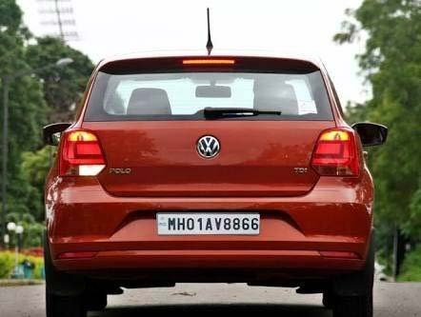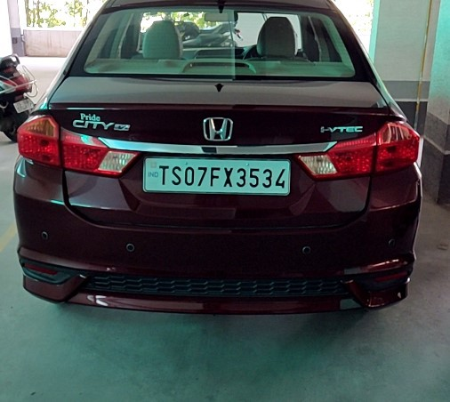

**Result:**

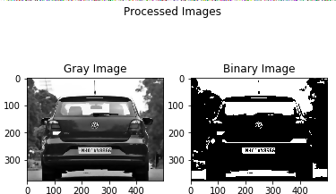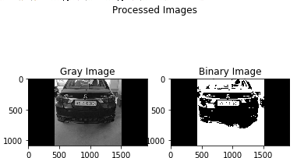

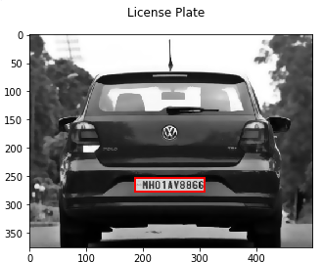 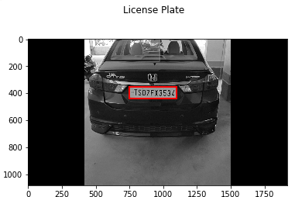

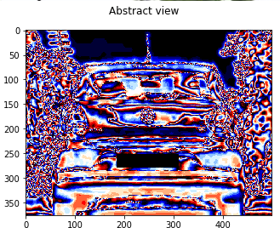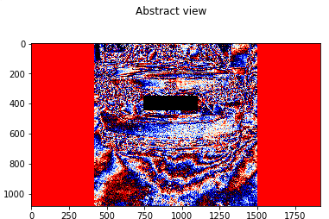

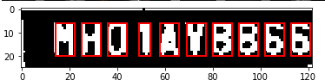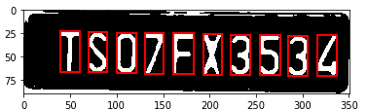

License plate is :| MHO1A¥8B66 License plate is :TSO7FX3534

## 6.1 Future Scope

1. ANPR can be further exploited for vehicle owner identification, vehicle model identification traffic control, vehicle speed control and vehicle location tracking.
2. It can be further extended as multilingual ANPR to identify the language of characters automatically based on the training data It can provide various benefits like traffic safety enforcement, security- in case of suspicious activity by vehicle, easy to use, immediate information availability- as compare to searching vehicle owner registration details manually and cost effective for any country For low resolution images some improvement algorithms like super resolution of images should be focused.*.*
3. Multiple vehicle number plate images considereation for ANPR

## CONCLUSIONS

ANPR system is one of the most sought after research topics in the current era and attracts a huge number of scholars too.number plate recognition can help traffic and government sectors in maintaining the database of vehicles in the country and catch-holding the fraud and unregistered vehicles thus reducing crime.

It is quite clear that ANPR is difficult system because of different number of phases and presently it is not possible to achieve 100% overall accuracy as each phase is dependent on previous phase. Certain factors like different illumination conditions, vehicle shadow and non-uniform size of license plate characters, different font and background color affect the performance of ANPR. Some systems work in these restricted conditions only and might not produce good amount of accuracy in adverse conditions.

Future work involves expansion of the field of research towards vehicle owner identification, vehicle model identification traffic control, vehicle speed control,vehicle location tracking and multilingual ANPR to identify the language of characters automatically.

## Appendix B

The team comprised of five members and each one of them had contributed well on their part.The efficiency of the team is surely reflected in the work showcased above.

**Vishal kumar singh (1705760 ,CSE)** : Had role in working on the preprocessing part of the image(image resizing,noise removal,gray scale conversion and binarising the image) so that the image can be better used for further purpose and number plate can be detected easily.Had equal contribution on document designing.

**Dipak kumar sinha (1705306, CSE)** : Had role in working on the preprocessing part of the video part i.e. finding the perfect clip that can be used for number plate detection and the preprocessing that clip (image resizing,noise removal,gray scale conversion and binarising the image) .Had equal contribution on document designing..Had equal contribution in study of the research papers.

**Utkarsh kumar (1705378 , CSE) :** Had done research work on the models built previously and contributed to the document by finding relevant data.Further helped in model by detecting the objects in the image that has dimensions similar to number plate and finally the number plate detection.

**Ayush kumar Rai (1705301 , CSE) :** Had done research work based on the topics relevent to the project and found the papers holding much importance for the project.Further helped in model by segmenting the character objects in the image after the detection of number plate from the image also known as segmentation.

**Niraj Kumar Kannaujiya (1705331 , CSE) :** Had contributed in document designing.Helped in model by recognising the characters after segmentation part and finally displaying the number on the number plate.

## REFERENCES

* + 1. <http://opencv.willowgarage.com/documentation/python/>
    2. A.Conci, J. E. R. de Carvalho, T. W. Rauber, A Complete System for Vehicle Plate Localization, Segmentation and Recognition in Real Life Scene, IEEE LATIN AMERICA TRANSACTIONS, VOL. 7, NO. 5, SEPTEMBER 2009
    3. Nobuyuki Otsu (1979). A threshold selection method from gray-level histograms. IEEE Trans. Sys., Man., Cyber. 9: 62-66.
    4. Chih-Hai Fana, Yu-Hang Peng, Vehicle License Plate Recognition System Design, Chung Hua Journal of Science and Engineering, Vol. 7, No. 2, pp. 47-52 (2009)
    5. https://[www.researchgate.net/publication/236888959_Automatic_Number_Pla](http://www.researchgate.net/publication/236888959_Automatic_Number_Pla) te_Recognition_System_ANPR_A_Survey